Samantha Naini
Info 233 – Programming in Visual Basic
Professor Klein
2/2/2012

HW: Exercise 2.2, #’s 25, 27 and 29

25)
'Exercise 2-2-25 Page 35'
'Programmer: Samantha Naini'
'Date: 1/30/2012'
'Program Purpose: Display in a window entitled "Dynamic Duo" with two buttons entitled "Batman" and "Robin" respectively.'

Option Explicit On
Option Strict On

Public Class Form1
Inherits System.Windows.Forms.Form

End Class

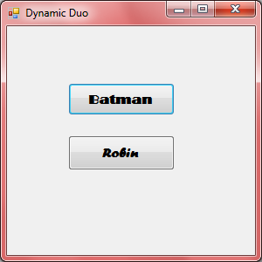

27)
'Exercise 2-2-27 Page 35'
'Programmer: Samantha Naini'
'Date: 2/2/2012'
'Program Purpose: Display a Titanic quote in a “fill in the blank” style.'

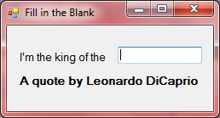
29)
'Exercise 2-2-29 Page 35'
'Programmer: Samantha Naini'
'Date: 2/2/2012'
'Program Purpose: Display a window titled “Uncle’s Advice” listing the three most important things in life with numbered buttons and corresponding labels.'

